High-fidelity prototype

# Description

**A high-fidelity prototype is digitalized: based on computer and created with specific software. Usually it allows the users to interact with it because it simulates the behaviour of the system as if it was coded. For example, if a user clicks on a button, the interactive prototype executes the specific command.**

# Benefits

* Complete functionality
* Fully interactive
* It defines clearly the navigational scheme
* Recommended for refining, testing and solving
* It brings a good look and feel of the final product
* Useful when planning to collect user performances (ex. number of errors, time to complete a task…)
* Useful in showing the future system to stakeholders
* Living specification for developers
* When it is used for testing, more detailed issues would be found as it is closer to the final system

Disadvantages:

* expensive and time consuming

# Best practices

Creation

* it should be created it based on previous prototypes and descriptions of use
* do not develop three or more high-fidelity prototypes at an early stage: it is a waste of time and sources
* consider that to create this kind of prototype is time-consuming and expensive
* it requires programming skills of the interface designer

Use

* provide a working prototype to programmers in order to
  + reference it when a written specification is unclear and/or they need more details
  + support them when developing the users’ manuals and help panels
* show to public how the system will work before it is fully developed
* test with users and stakeholders

# Examples

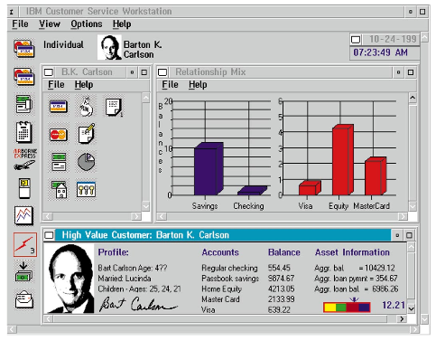  
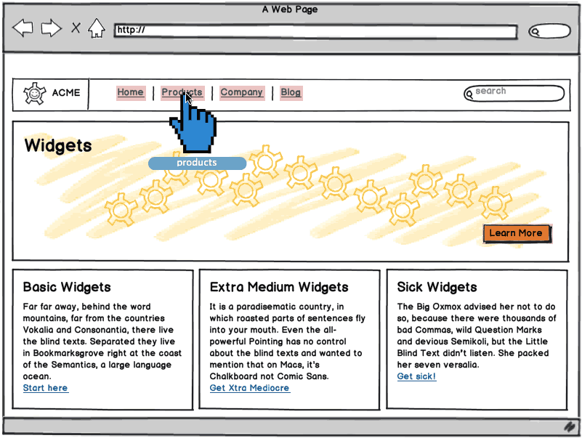

<http://support.balsamiq.com/customer/portal/articles/107999>

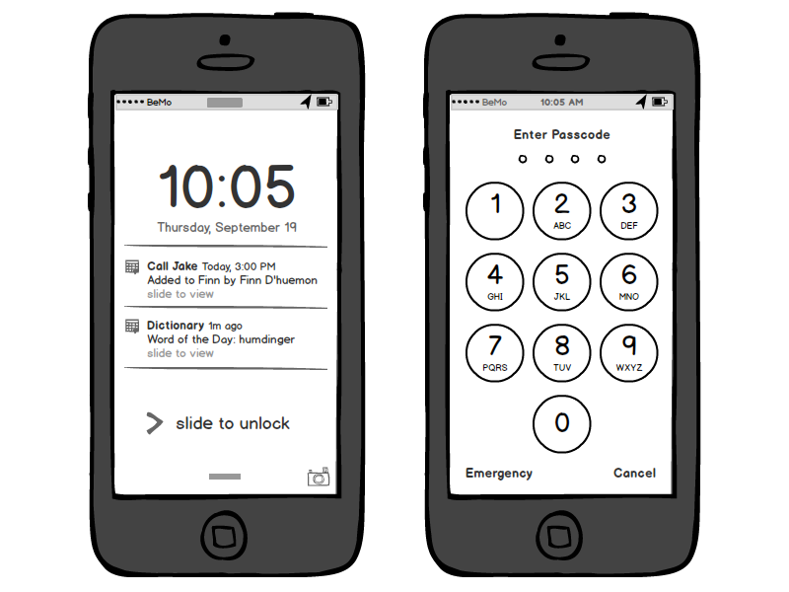

http://balsamiq.com/products/mockups/

<http://www.usability.gov/how-to-and-tools/methods/prototyping.html>

libro p. 120

@article{Rudd:1996:LVH:223500.223514, author = {Rudd, Jim and Stern, Ken and Isensee, Scott}, title = {Low vs. High-fidelity Prototyping Debate}, journal = {interactions}, issue_date = {Jan. 1996}, volume = {3}, number = {1}, month = jan, year = {1996}, issn = {1072-5520}, pages = {76--85}, numpages = {10}, url = {http://doi.acm.org/10.1145/223500.223514}, doi = {10.1145/223500.223514}, acmid = {223514}, publisher = {ACM}, address = {New York, NY, USA}, }